Continuous Integration and Continuous Deployment Lab

Experiment – 3

**Name – Harivansh Mathur**

**Roll No – R171218043**

**Jenkins Integration with GitHub and Maven**

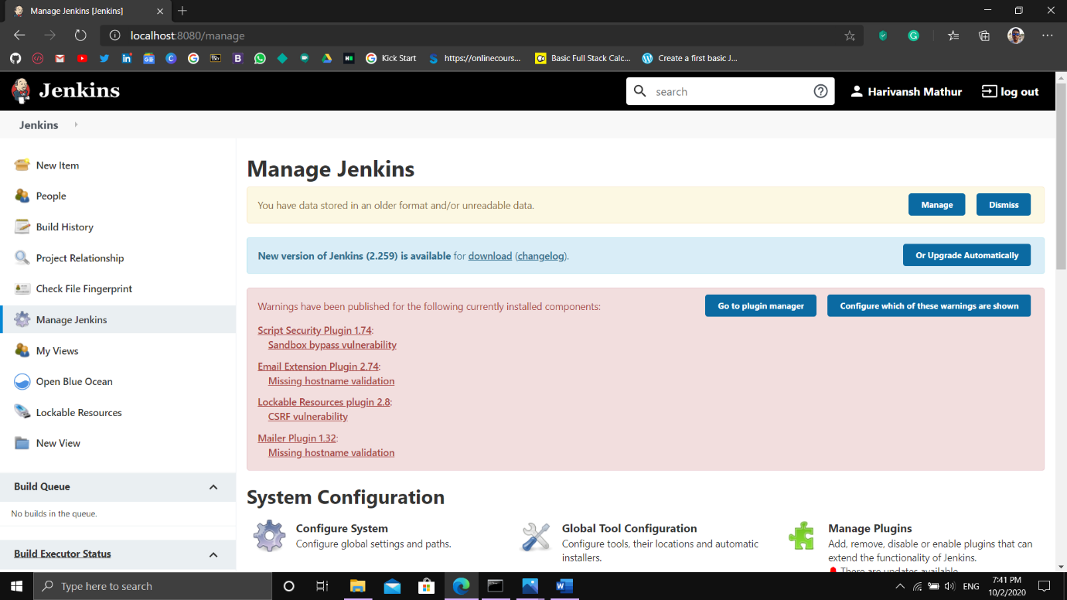

On Jenkins Dashboard, go to Manage Jenkins and select Global Tool Configuration

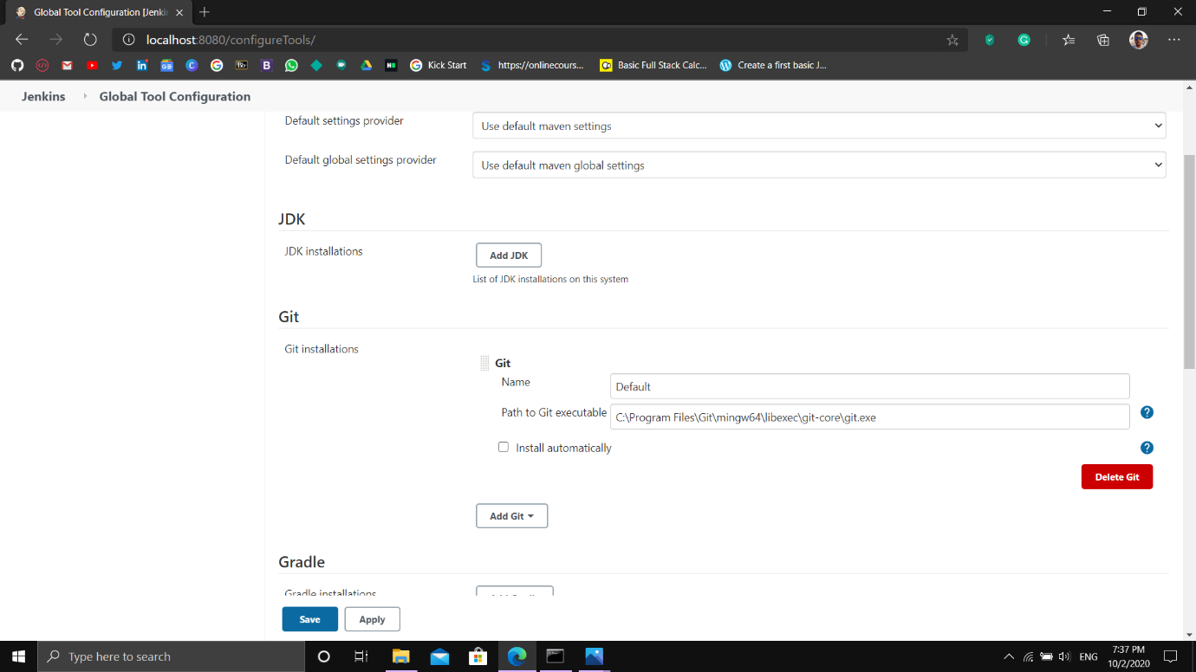

Add Git directory in this section and apply and save the changes

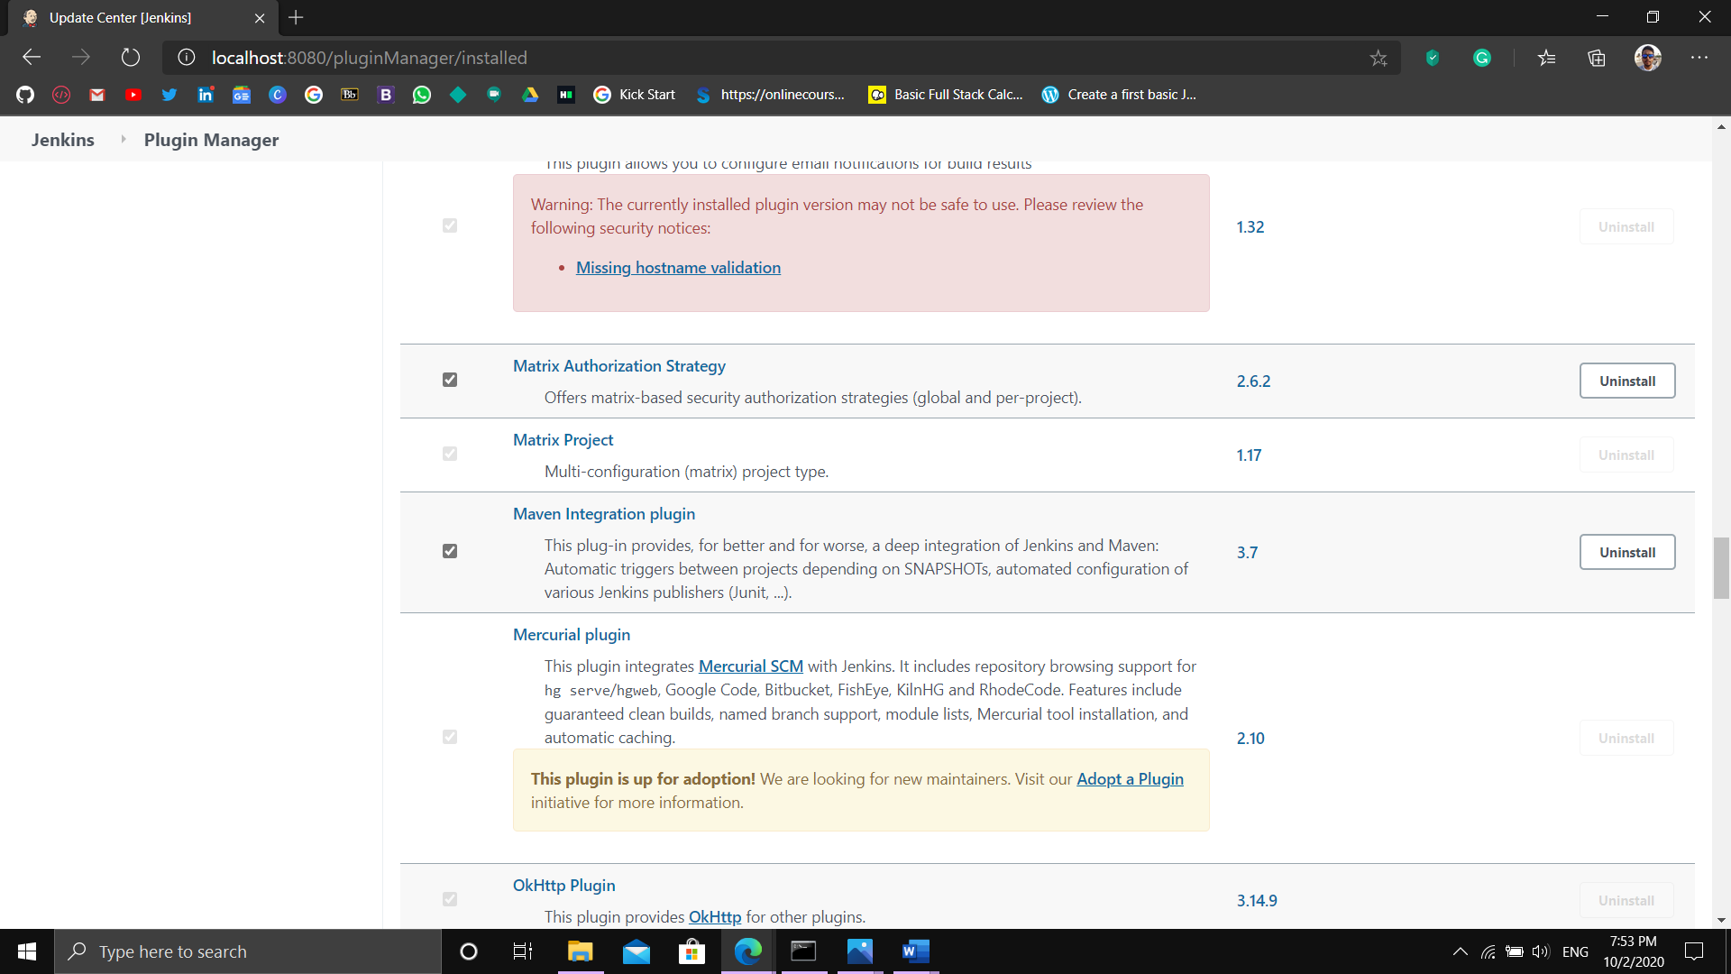

For Integrating Maven we install the Maven Plugin in Jenkins in Manage Plugins Section

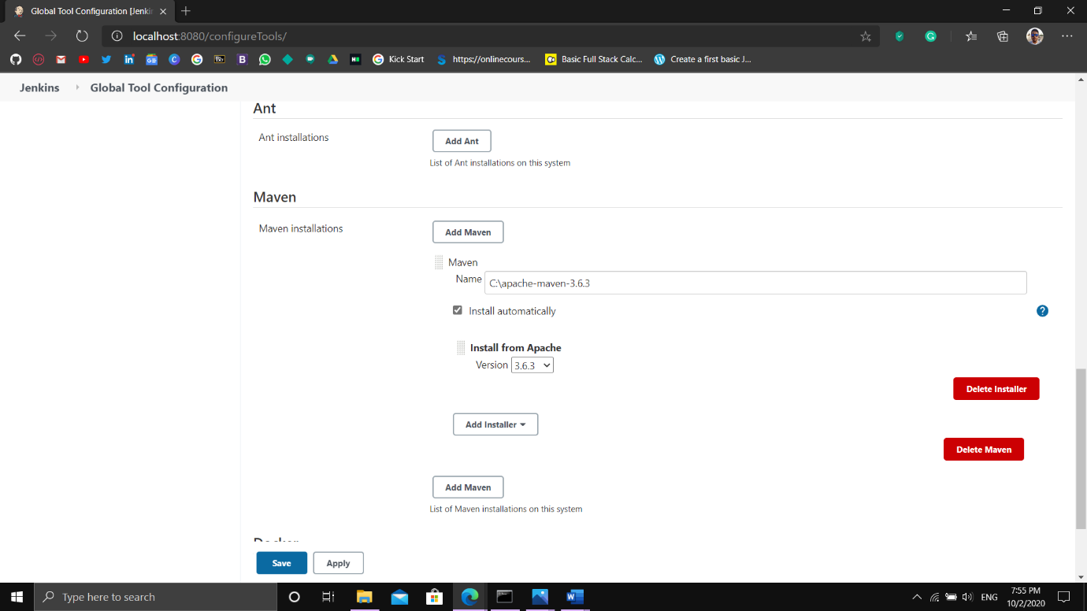

In Global Tool Configuration link the maven file as where it is stored locally on the system